# Download Tool

Download Tool is a GUI tool provided with the InnoPhase Talaria TWO SDK. The Download Tool is provided as binaries for Windows and Linux Operating Systems.

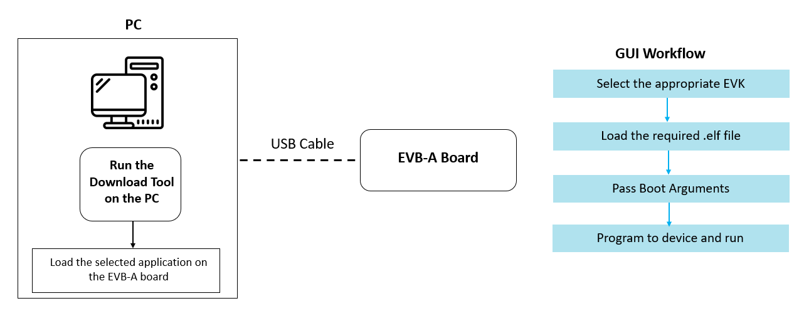

Figure 1: Block Diagram